**R-Ladies Melbourne Christmas Party - Answer to the R-Trivia questions** 

**Round 1 - R related history**

#### Name two people that invented the S programming language, the predecessor of R? John Chambers & Rick Becker

There were others present at the beginning of S development!



#### What does CRAN stands for? The Comprehensive R Archive Network

#### How many CRAN mirrors are there for Australia? 2 - CRAN mirrors are country-specific repositories to download R

#### Who is the author of Advanced R & R Packages books? Hadley Wickelm

#### Where is the next UseR (UseR! 2017) conference going to be held? Brussels, Belgium

**Round 2 - General R**

#### What is the most popular CRAN package for data visualisation based on grammar of graphics? ggplot

#### What is the expression that signals skipping the current iteration and going to the next iteration in a loop? next

#### What is the command set before generating random numbers that ensures reproducibility? set.seed()

#### Name at least one R package for Parallel programming/parallelization. parallel, snow

#### What is the the function that writes console output to a file? sink()

**Round 3 - Visualisation**

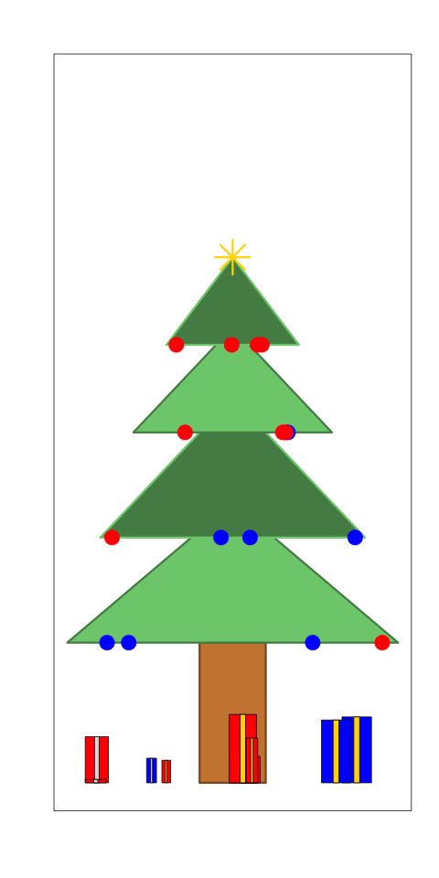

1. Which plotting functions have been used to produce the Christmas trees? polygon, plot, points, rect. You can find the code at https://gist.github.com/jtleek/4369771
2. Which function made me?

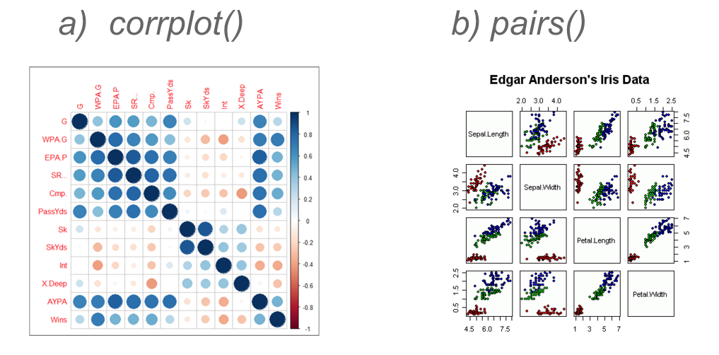

1. Which functions have been used to set plots on the same figure?

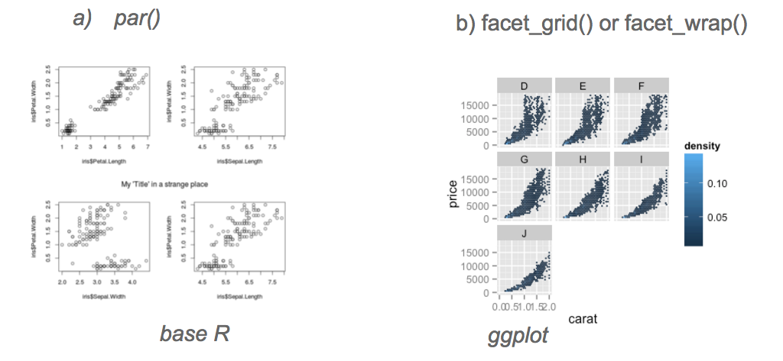

1. Which ggplot ‘geom’ am I ? geom_boxplot()
2. Which ggplot ‘geom’ am I ? geom_bar()

**Round 4 - R and other systems**

#### The Rstudio Service that facilitates interactive data analysis is: a) Rstudio Server b) Shiny c) RMarkdown

1. What is the R package that allows R and C++ flawless integration? Rcpp

#### State a file format for making dynamic documents with R - Rmarkdown

#### How can you install packages from CRAN and GitHub? install.packages() install_github()/devtools()

#### What is the function used to execute command-line/shell commands from within R? system()

**Round 5 - Functions**

1. The command to check if all rows in a matrix/data frame have non-NA values? - complete.cases(), is.na()
2. Which code is more efficient ( m is a matrix)?
   * 1. for (i in 1:ncol(m)) { sum(m[ ,i]) }
     2. apply(m, 2, sum)
     3. colSums(m) - because of vectorisation
3. Name a function that lists files in a directory based on a pattern or a suffix list.files(), dir()
4. which of the following commands return the indices of the matched patterns?
   1. grep(pattern, x) - returns index
   2. grep(pattern, x, value = TRUE) - returns the grepped value
   3. grep(pattern, x, invert = TRUE) - returns everything but the one with matches to the pattern specified

**Spurious Correlation website!**

**http://www.tylervigen.com/spurious-correlations**

**Team Name ________________**

**Round 1 - R related history /5**

1. _____________________________
2. _____________________________
3. _____________________________
4. _____________________________
5. _____________________________

**Round 2 - General R /5**

1. _____________________________
2. _____________________________
3. _____________________________
4. _____________________________
5. _____________________________

**Round 3 - Visualisation /5**

1. _____________________________
2. a) __________________________ (½ point)

b) __________________________ (½ point)

1. a) __________________________ (½ point)

b) __________________________ (½ point)

1. _____________________________
2. _____________________________

**Round 4 - R and other systems /5**

1. _____________________________
2. _____________________________
3. _____________________________
4. _____________________________
5. _____________________________

**Round 5 - Functions /4**

1. _____________________________
2. _____________________________
3. _____________________________
4. a) b) c)

Total /24